# Public Transport Project

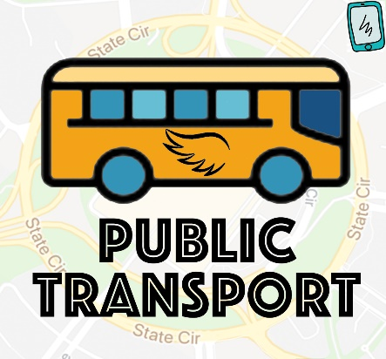 **GovHack Team 501**

**Qiuxi Shi**

**Hui Ren**

**08/09/2019**

Contents

*Public Transport Project* 1

Data Analysis 3

Data Preparation 3

Data Preprocessing 3

Data Analyzing and Result 3

Requirements Document 5

1. Introduction 5

2. Development significance 5

3 Functions 6

3.1 Main functions 6

3.2 Functional Description 6

3.3 Functional Diagram 6

3.4 Entity Relationship Diagram (E-R) 8

3.5 Main Case Description 9

4. System 10

5. System Model 11

5.1 Login Page 11

5.2 Map Page 11

5.3 Discussion Page 15

5.4 Individual Page 15

6. Future Vision 17

# Data Analysis

# Data Preparation

Challenge

* Public Transport for the Future
* Canberra 2029 – First Hackers: Inclusive; Progressive; Connected

Data related public transport from Open Data Portal dataACT use used, table names are below and detail addresses are referred in the references.

* Passenger Journeys by Week by Ticket Type
* On Time Running by Week - First Stop Only
* Budget 2017-2018 - by category table
* Budget 2018-2019 - by category table
* Budget 2019-2020 - by category table
* ACT Population Projections

Main idea is cleaning all data prepared and import these formalized data into models, which created in the Modeler to form diagrams.

# Data Preprocessing

Using Excel to make data cleaning. Combine budget from recent years, list the sum number as an attribute. When data comes from week by week, choose the first week and the last one or choose the last one.

# Data Analyzing and Result

Create a model in SPSS Modeler to display data by several clear diagrams.

About the on-time rate, select the data as x field and the on-time rate as y field. It shows a decline trend despite the fluctuation. The second graph shows population can be one factor, when analysing, firstly merging two kinds of data, one is the on-time rate and the other is the population, to combine the population and the time, then choosing the two attributes as the x and y field.

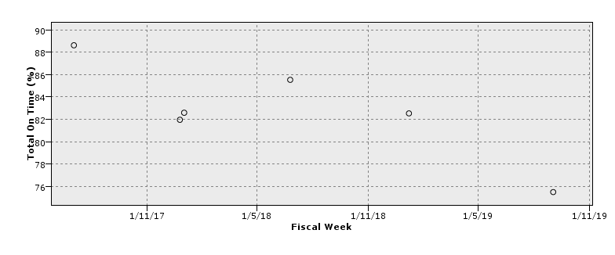



The diagram below shows relationship about the number of people, the number of the transport card, that of paper ticket and the year. As the growing of population, the card is also increasing and the papa ticket number rapidly declined despite some waves.

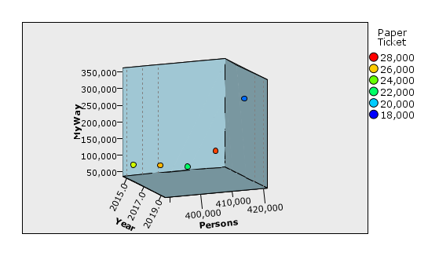

From 2017 to 2019, there is fluctuation about the real budget financing, and the trend is decreasing. While from 2020 forwards, it can be clearly seen that the government want to keep decreasing the budget financing.

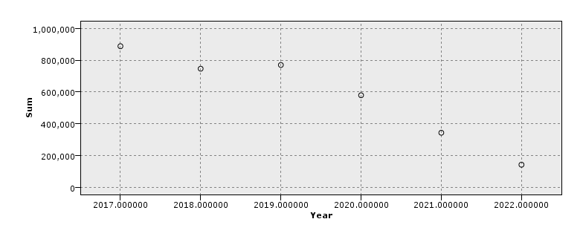

# Requirements Document

# 1. Introduction

Although Canberra has launched its new public transport system not long ago, there seem to exist a gap between the new system’s real performance and passengers’ expectations. The ACT government has been swamped with passengers’ complaints including driver shortage, unpunctuality, late announcement of malfunction, missing bus stop alert, traffic congestion, etc. These existing problems not only degrade the travel experience of passengers but also pose a challenge to government transport administration. After the analysis of open data of ACT transport, we concluded that the underlying reason of this negative phenomenon is inefficient communication between passengers and transport operators, hence, in the short run, an app named EasyWay with a set of integrated functions is devised to streamline the entire transport service from departure to arrival while in the long run, we recommend to introduce self-driving electric vehicles to fulfill sustainability.

# 2. Development significance

There are 3 entries for 2 kinds of users: passengers, authorized officers. For passengers, functions are displayed as follows

* daily announcement of
* recommendation for personalized route
* estimate expense of travel price and travel time
* real time bus/light rail tracker
* anonymous comment towards the degree of safety, punctuality and crowdedness after trip is finalized
* link to credit/debit card
* display bar code to pay for the trip

For authorized officers, functions are displayed as follows

* age of the buses in operation → guide maintenance service
* incident rate → guide driver management
* visualization of passengers’ real-time feedback → guide flexible route rearrangement

# 3 Functions

## 3.1 Main functions

Four modules of this system:

Login

Map

Comment

Online Service

## 3.2 Functional Description

## 3.3 Functional Diagram

Data Flow Diagram（DFD)

Top Level



Level 1



Level 2



Level 3







## 3.4 Entity Relationship Diagram (E-R)

Passenger:



Government:



Driver:



Relationship:



## 3.5 Main Case Description

Government:

Login

Supervise lines

Interact with Drivers

Discussion

Address complaints

Passenger:

Login

Search lines

Comment

Discussion

Personalized Transport Recommendation

Driver

Login

Search lines

Report transport situation

Interact with government

Discussion

Calling system

# 4. System

(1) Performance

The reaction time after each operation is less than 6 seconds.

User's information is passed to the background no more than 4 seconds.

Some document in the system that can be downloaded should be in less than 8 second

by a modem with a speed of 40KBps.

(2) Modifiability

Personal information can be modified in real time (except audit information).

The original data modification is simple, convenient, and it supports multiple condition modification.

(3) Usability

Convenient data query, support for multi-condition query and screen.

For current computers, low-performance computers may have an impact on speed.

(4) Friendly interface;

According to the text or prompt of the interface, user can complete the operation of

the system.

(5) Security

All network transactions involving functional information or personal private identity

information are encrypted.

In addition to browsing the main interface, users must log in to complete other

operations.

Only authorized administrators can review and deleted information through the

system.

Users can only browse some of their own information records and cannot browse

other users' browsing messages, etc.

# 5. System Model

## 5.1 Login Page

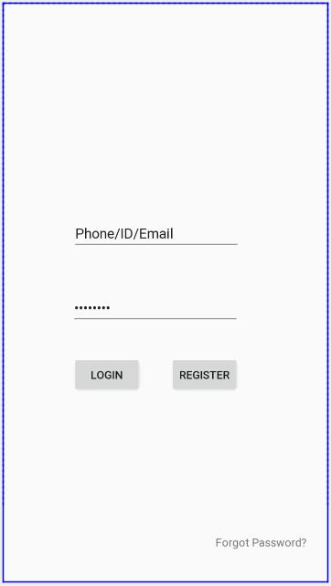

## 5.2 Map Page

Passenger

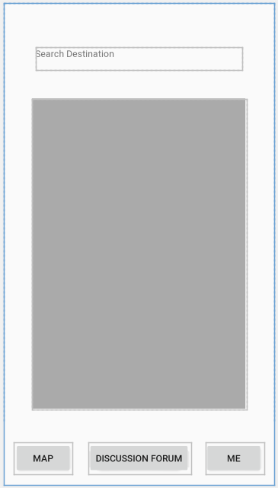

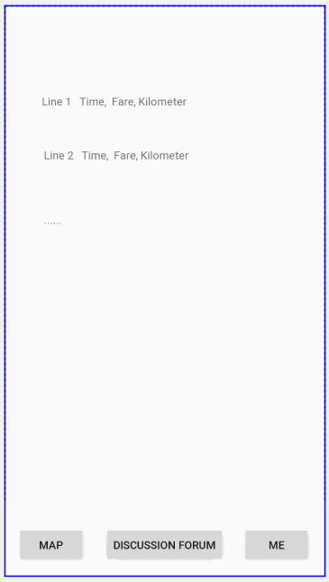

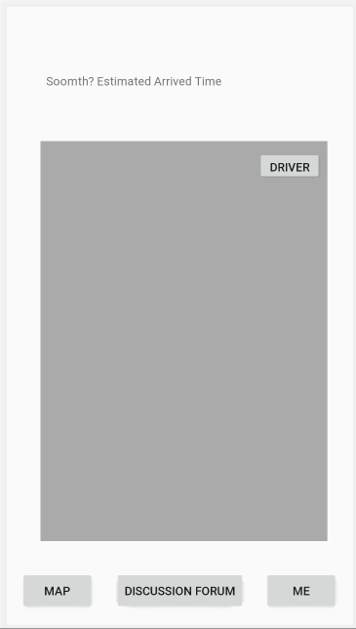

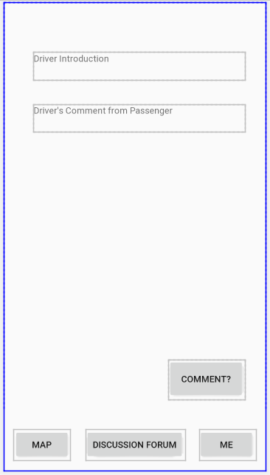

Driver

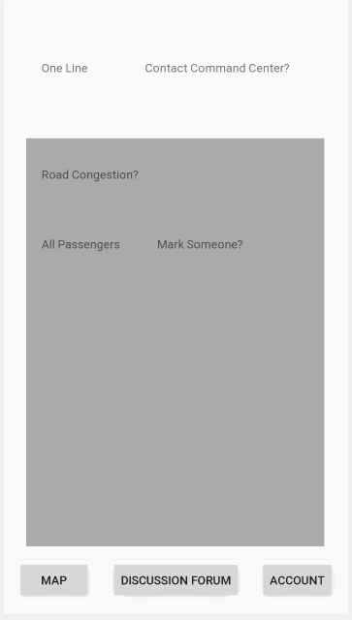

Government

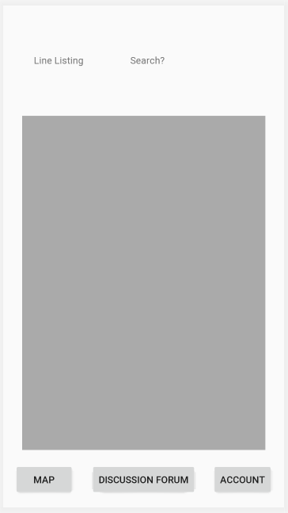

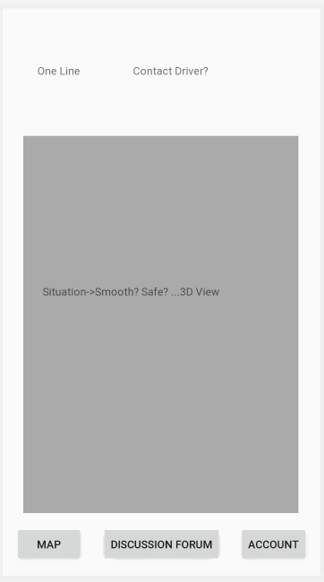

## 5.3 Discussion Page

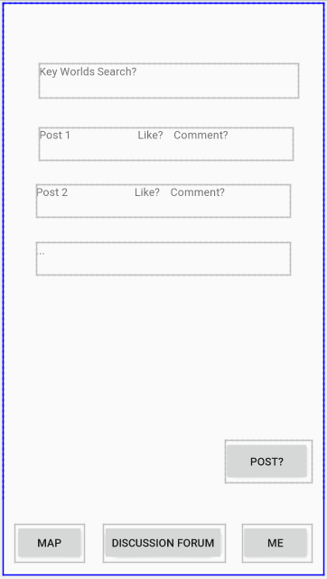

## 5.4 Individual Page

Passenger

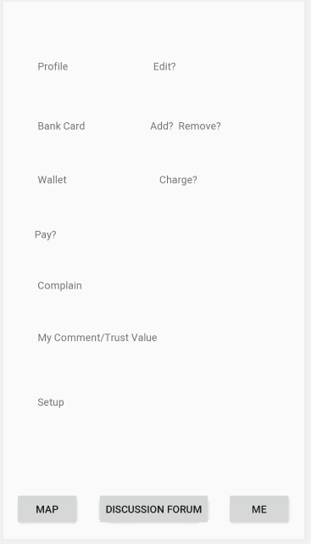

Driver

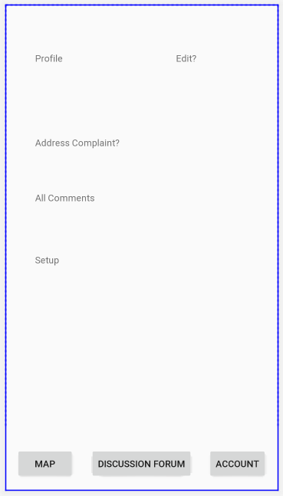

Government

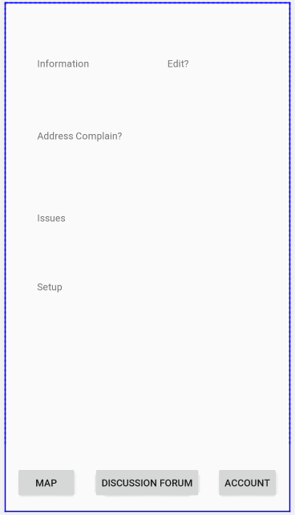

# 6. Future Vision

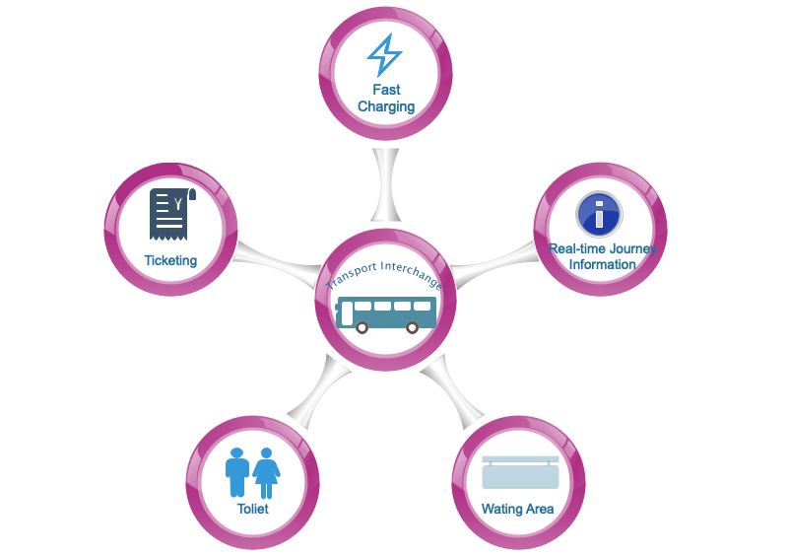

As from the government budget financing trend, in the future, officials want to save much budget, while the population is growing and they still need to consider much public infrastructure including transport. Driverless public transport can realize it as well as bring much more convenience. Staff can sit in working room and supervise transport lines. All things like driving, turning left or right, stopping are automatically working. Such driverless transport combined with the payment attached to mobile phones shows the rapidly developing technology.

**References**

Passenger Journeys By Week By Ticket Type retrieved from <https://www.data.act.gov.au/Transport/Passenger-Journeys-By-Week-By-Ticket-Type/jia3-rxue>

On Time Running By Week - First Stop Only retrieved from <https://www.data.act.gov.au/Transport/On-Time-Running-By-Week-First-Stop-Only/diwx-p2be>

Budget 2017-2018 - by category table retrieved from <https://www.data.act.gov.au/Government-and-Transparency/Budget-2017-2018-by-category-table/dxuq-hc4u>

Budget 2018-2019 - by category table retrieved from <https://www.data.act.gov.au/Government-and-Transparency/Budget-2018-2019-by-category-table/dkp7-zmia>

Budget 2019-2020 - by category table retrieved from <https://www.data.act.gov.au/Government-and-Transparency/Budget-2019-2020-by-category-table/gtu5-8j7s>

ACT Population Projections retrieved from <https://www.data.act.gov.au/People-and-Society/ACT-Population-Projections/y438-27ka>